**Introduction**

The chi-square test for association tests for whether two categorical variables are associated. Another way to phrase this is that this test determines whether two variables are statistically independent. For this reason, this test is also often referred to as the **chi-square test of independence**. More specifically, it tests for the association/independence between two nominal/dichotomous variables. You can test for ordinal variables, but you will lose the extra information provided by knowing the order of the categories. This test does not distinguish between dependent and independent variables, although your study design might do so.

For example, you could use a chi-square test for association to determine whether there is an association between whether a person exercises and the presence of heart disease (i.e., your two nominal variables would be "exercise", which has two groups – "exercises" and "does not exercise" – and "presence of heart disease, which also has two groups: "yes" and "no". If there is an association (positive or negative), you can also determine the strength/magnitude of this association. As another example, you could use a chi-square test for association to determine whether there is an association between brand preference and gender in terms of sports cars (i.e., your two nominal variables would be "car brand preferences", which has five groups – Audi, BMW, Land Rover, Mercedes and Porsche – and gender, which has two groups: "males" and "females". Again, if there is an association (positive or negative), you can also determine the strength/magnitude of this association.

**Requirements for Chi-Square**

*Assumption #1*: You have two categorical variables. A categorical variable can be either nominal or ordinal; however, if you have an ordinal variable it is better to use a different test statistic. Examples of **nominal variables** include gender (two groups: males or females), ethnicity (e.g., three groups: Caucasian, African American and Hispanic), profession (e.g., five groups: surgeon, doctor, nurse, dentist, therapist), and so forth.

*Assumption #2*: You should have independence of observations. This means that there is no relationship between the observations in the groups of the categorical variables or between the groups themselves. Indeed, an important distinction is made in statistics when comparing values from either different individuals or from the same individuals. Independent groups (in a chi-square test for association) are groups where there is no relationship between the participants in any of the groups. Most often, this occurs simply by having different participants in each group.

For example, imagine that a teacher wants to know if there is an association between gender and a person's preferred learning medium. In such an example, you have two nominal variables: "gender" (with two groups: "males" and "females") and "preferred learning medium" (with two groups: "online" and "books"). Independence of observation means that no person in the female group can also be in the male group (and vice versa). Similarly, a person cannot prefer the online medium and books. They can only prefer either the online medium or books. This will be true of any independent groups. In actual fact, the 'no relationship' part extends a little further and requires that participants in both groups are considered unrelated, not just different people; for example, participants might be considered related if they are husband and wife, or twins. Furthermore, participants in Group A cannot influence any of the participants in Group B, and vice versa.

*Assumption #3*: All cells should have expected counts greater than five.

**What does the chi-square test do?**

The chi-square test for association determines whether there is an association between two nominal variables. It does this by comparing the observed frequencies in the cells to the frequencies you would expect if there was no association between the two nominal variables. As the expected frequencies are predicated on there being no association, the greater the association between the two nominal variables, the greater you would expect the observed frequencies to differ to the expected frequencies. The converse is also true. The less the two nominal variables are associated, the closer the observed frequencies will be to the expected frequencies. Indeed, this is how the chi-square test for association works. It produces a statistic based on the overall "amount" of difference between the expected and observed frequencies. The further the observed frequencies are to the expected frequencies, the larger the test statistic, the greater the association and the more likely a statistically significant result (i.e., indicating that an association exists).

**Example**

A researcher knows that in the general population of active individuals, males tend to engage in competitive sports whilst females prefer non-competitive sport/exercise. The researcher would like to investigate whether this is the case for males and females that are currently enrolled in an Exercise Science degree course. They asked 25 males and 25 females whether they predominately participate in competitive sport or non-competitive sport/exercise.

Whether participants predominantly participated in competitive or non-competitive sport was recorded in the variable, comp, whilst their gender was recorded in the variable, gender. In variable terms, the researcher wants to know what the association is between gender and comp.

In this example, the three variables we need to set up are:

1) The dichotomous variable, gender, which has two groups with "Male" coded "1" and "Female" coded "2";  
2) The dichotomous variable, comp, which has two groups with "Yes" coded "1" (i.e., participants who predominately participate in competitive sport) and "No" coded "2" (i.e., participants who predominately participate in non-competitive sport/exercise);  
    and  
3) The variable, freq, which captures the total count data (i.e., frequencies) for the two nominal variables above (i.e., the number of participants for each cell combination).

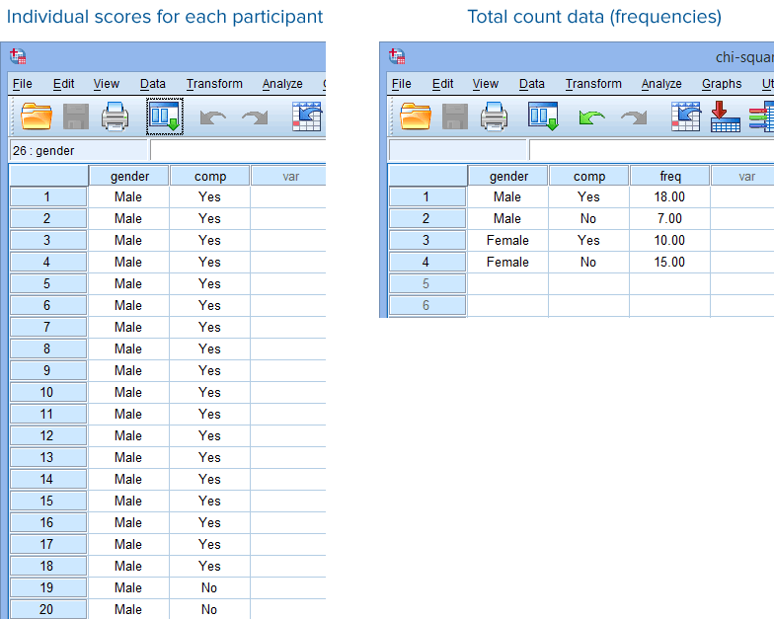How you set up your data in SPSS Statistics will depend on whether you have the **individual scores for each case** (e.g., where a case could be a participant) or if you have **total count data (i.e., frequencies)**. These two options are illustrated in the **Data View** window of SPSS Statistics below:

**Setting up your dataset**

Go to “Variable View.”

Rename variable “VAR00001” to “Gender.”

Change values to: Male = 1 and Female = 2

Rename variable “VAR00002” to “Comp.”

Change values to: Yes = 1 and No = 2

Change “Measure” to “Nominal” for both variables.

Change “Role” to “None” for both variables.

**Running the Chi-Square Test**

1. Click **Analyze > Descriptive Statistics > Crosstabs...** on the main menu, as shown below:

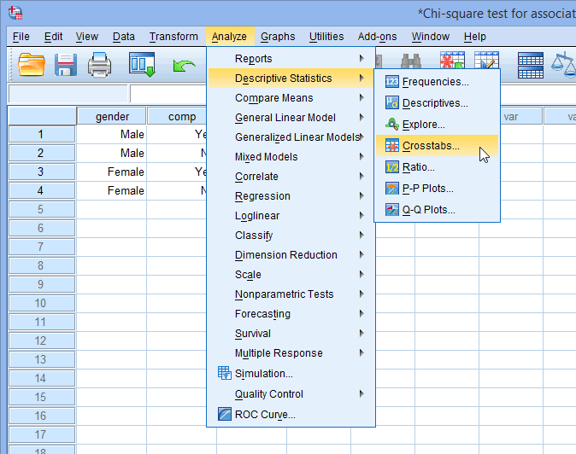

1. Transfer the variable gender into the Row(s): box and the variable comp into the Column(s): box by highlighting them and clicking on the relevant https://statistics.laerd.com/premium/spss/cstfa/img/right-arrow-button.png button. Also, select Display clustered bar charts. You will end up with the following screen:

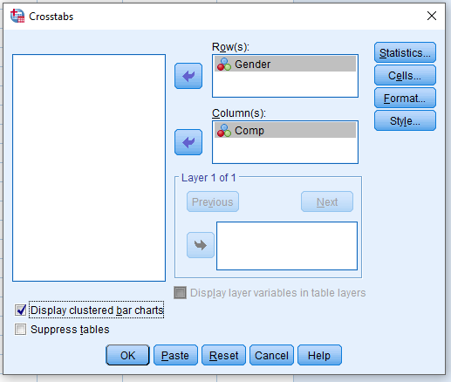

1. Click on the https://statistics.laerd.com/premium/spss/cstfa/img/statistics-button.png button. You will be presented with the **Crosstabs: Statistics** dialogue box. Select Chi-square and then select Phi and Cramer's V in the –Nominal– area, as shown below:

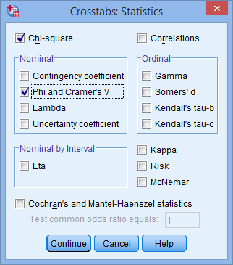

1. Click the https://statistics.laerd.com/premium/spss/cstfa/img/continue-button.png button. You will be returned to the **Crosstabs** dialogue box.
2. Select Expected in the –Counts– area and Row, Column and Total from the –Percentages– area, as shown below:

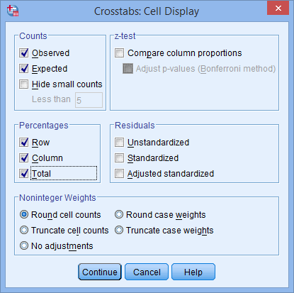

1. Click the https://statistics.laerd.com/premium/spss/cstfa/img/continue-button.png button. You will be returned to the **Crosstabs** dialogue box.
2. Click the https://statistics.laerd.com/premium/spss/cstfa/img/ok-button.png button to generate the output.

**Interpreting the Output**

*Assumption #3*: All cells should have expected counts greater than five.

Do all of the cells have expected counts greater than five?

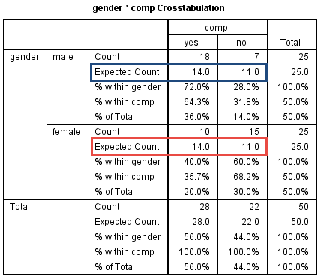

In this example, you can see that the expected count is greater than five in each of the four cells. The expected counts for males and females who predominantly participate in competitive sport are **14**, whilst the expected counts for males and females who predominantly participate in non-competitive sport are **11**. Therefore, the assumption that all cells should have expected counts greater than five has been met.

You could report the results for this assumption as follows: A chi-square test for association was conducted between gender and preference for performing competitive sport. All expected cell frequencies were greater than five.

The **Case Processing Summary** table highlights how many valid and missing cases (e.g., participants) there are, as shown below:

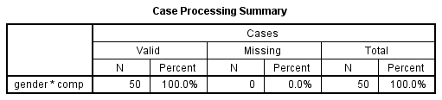

SPSS Statistics highlights the crosstabulation of the two variables as gender*comp. You can see here that all cases were valid ("50" under the "**Valid**" column) and there were no missing cases ("0" under the "**Missing**" column).

*Crosstabulation*

The crosstabulation and observed and expected frequencies for each cell of the design are found in the **gender*comp Crosstabulation** table, as shown below:

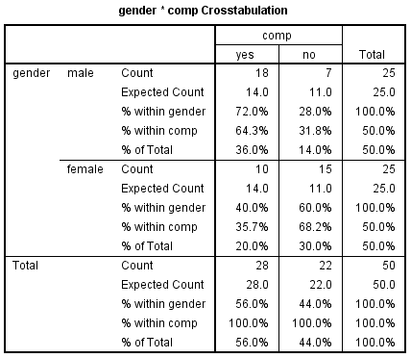

You should look at the expected and observed counts for the two variables, as highlighted below:

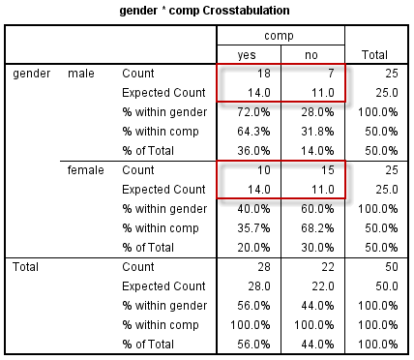

From these results, you can see that for "males", the observed frequency was somewhat greater than expected for "yes" to competitive sports, and lower than expected for "no" to competitive sports, and in "females", the other way around. This might lead you to suspect that there is an association between these two variables. You can test for this formerly in the next section.

*Chi-Square test for association*

The results of many statistical tests, including the chi-square test for association, are presented in the **Chi-Square Tests** table, as shown below:

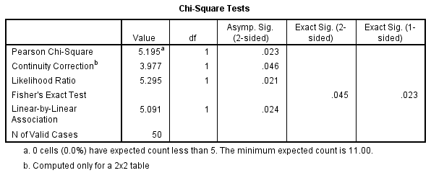

When you have a 2 x 2 crosstabulation (i.e., where both variables are dichotomous, meaning that they only have two categories), as in our example, you can choose to use the result of either the chi-square test for association ("**Pearson Chi-Square**" row) or Fisher's Exact test ("**Fisher's Exact Test**" row). If one or both of your variables has more than two categories, you cannot use Fisher's Exact test.

Although there are different recommendations for using Fisher's Exact test, one common recommendation is to use Fisher's Exact test when you have a small sample size (i.e., when you have one or more expected cell frequencies less than five) (Blalock, 1972).

You can determine whether the chi-square test for association is statistically significant by consulting the cell in the "**Pearson Chi-Square**" row under the "**Asymp. Sig. (2-sided)**" column, as highlighted below:

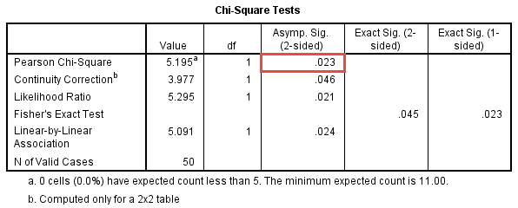

You can see that the statistical significance value (i.e., *p*-value) is **.023** (i.e., *p* = .023). If *p* < .05, you have a statistically significant result, whereas if *p* > .05, you do not have a statistically significant result. Our *p*-value of .023 is less than .05 (i.e., *p* = .023 satisfies *p* < .05). Therefore, we have a statistically significant result; that is, there is a statistically significant association between our two dichotomous variables.

You could report this as follows: A chi-square test for association was conducted between gender and preference for performing competitive sport. All expected cell frequencies were greater than five. There was a statistically significant association between gender and preference for performing competitive sport, χ2(1) = 5.195, *p* < .05.

You can also report any numbers or percentages from the crosstabulation table that you feel are appropriate to explain your results.

*Fisher’s Exact Test*

If you used Fisher's Exact test to determine if there was an association between the two dichotomous variables, you need to consult the cell in the "**Fisher's Exact Test**" row under the "**Exact Sig. (2-sided)**" column, as highlighted below:

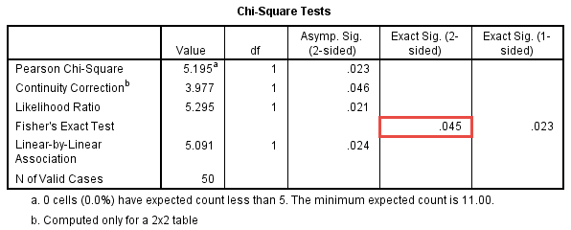

You can see that the statistical significance value (i.e., *p*-value) is **.045** (i.e., *p* = .045). Just like with the chi-square test result, if *p* < .05, you have a statistically significant result, whereas if *p* > .05, you do not have a statistically significant result. Our *p*-value of .045 is less than .05 (i.e., *p* = .045 satisfies *p* < .05). Therefore, we have a statistically significant result; that is, there is a statistically significant association between our two dichotomous variables.

You could report the result as follows: A Fisher’s Exact test was conducted between gender and preference for performing competitive sport. There was a statistically significant association between gender and preference for performing competitive sport, *p* < .05.

*Strength of association*

The major problem with the chi-square test for association is that although it informs you whether you can reject the null hypothesis of no association, it does not inform you of the strength/magnitude of any association. Two measures that do provide measures of effect size are presented in the **Symmetric Measures** table, as shown below:

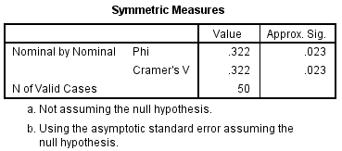

Phi (φ) and Cramer's V are both measures of the strength of association of a nominal by nominal relationship. Phi is only suitable when you have two dichotomous variables. Phi and Cramer's V will provide the same answer when you have a 2 x 2 crosstabulation, although Phi is usually reported in these situations. Phi is not suitable for anything other than 2 x 2 tables, so in all other cases you should use Cramer's V. Both these measures can be interpreted in the same manner as a correlation (Phi ranges from -1 to +1). The major problem with these measures is that, under certain conditions, the maximum ranges can differ from -1 to +1.

**Reporting everything together**

You could report the results from a chi-square test for association and strength/magnitude of any association as follows:

A chi-square test for association was conducted between gender and preference for performing competitive sport. All expected cell frequencies were greater than five. There was a statistically significant association between gender and preference for performing competitive sport, χ2(1) = 5.195, *p* < .05. There was a moderately strong association between gender and preference for performing competitive sport, ɸ = 0.322, *p* < .05.

*Graphing the output*

By selecting to show a clustered bar chart in the **Crosstabs** procedure, you will have generated the following graph:

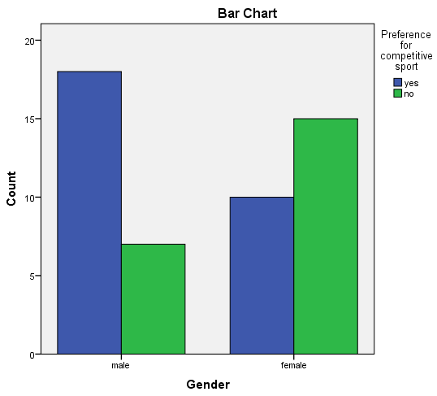

This can provide a good visual representation of your data. In this example, you can see quite clearly the differences in preference for competitive sports in males vs females.